Design Patterns Course – Exercise 1

# First App Feature – Match Maker:

Provides the user with the ability to find a friend from his friends list which made the highest number of likes to his posts.

The friends list can be filter by gender and desired age range, according to the user’s preferences.

The app will return the Matched soul mate with his full details (including profile picture, relationship status, location, status and more).

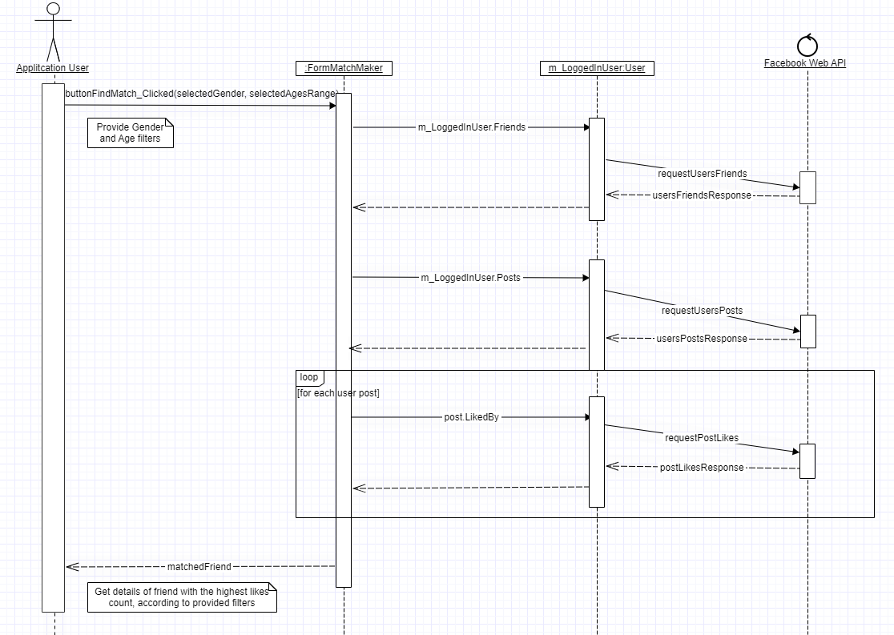**Sequence Diagram:**

# Second App Feature – Events Finder:

Provides the user with the ability to find Events to which his friends are attending, according to desired list of filters (Event time, Friend’s gender, Friend’s age range, etc.).

The app will return a list of matching events.

**Sequence Diagram:**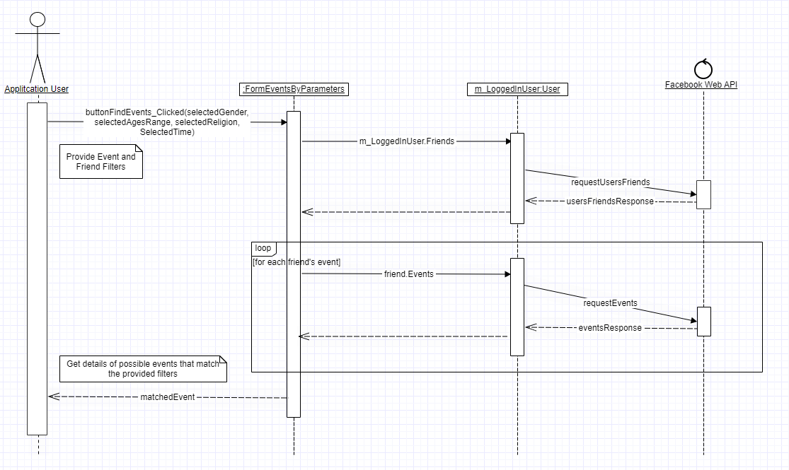

# Application Class Diagram:

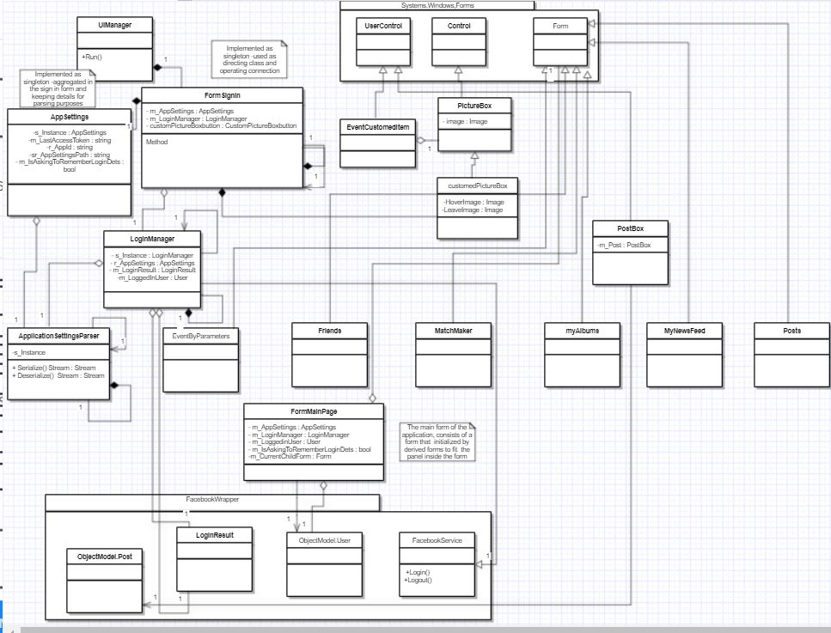

# Application Use Case Diagram:

